1. for notepad and caluclator.

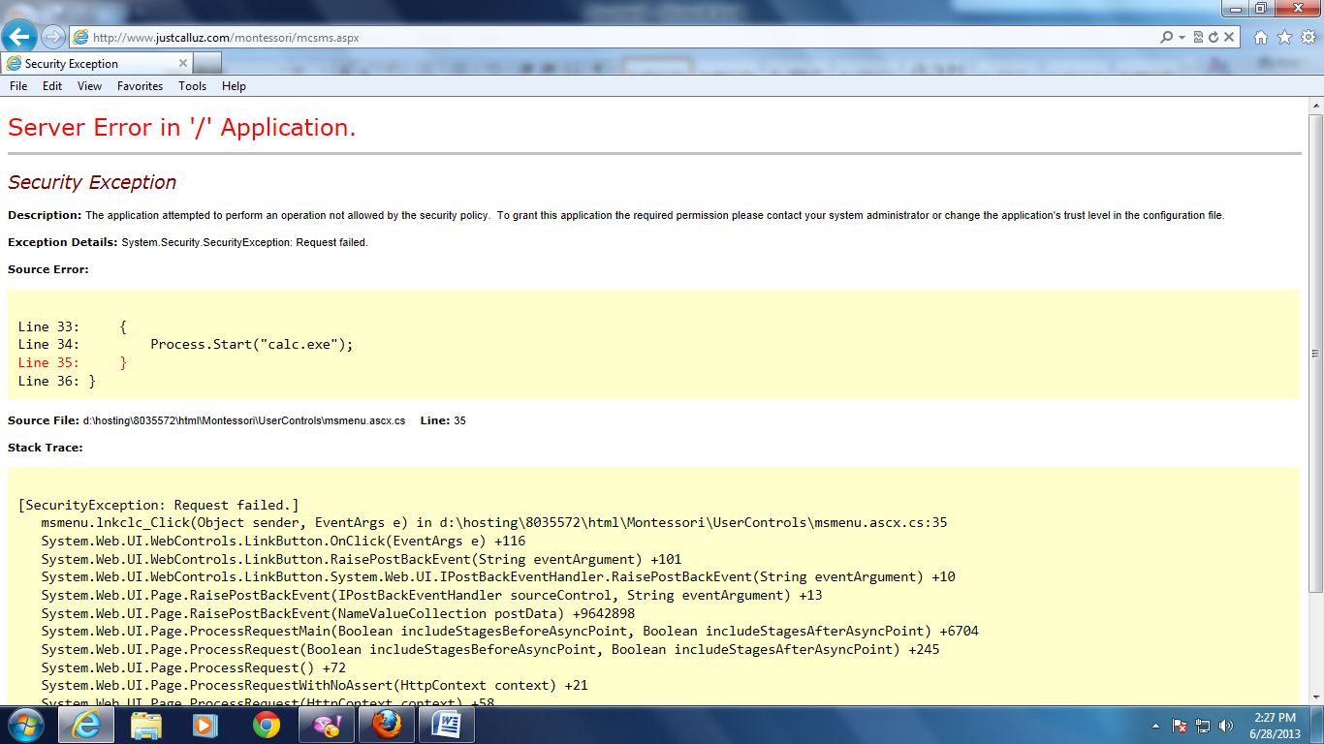

**Accounts :**

2. In account category,insert fee information design alignment is not properly displaying.when we click on find total after selecting terms

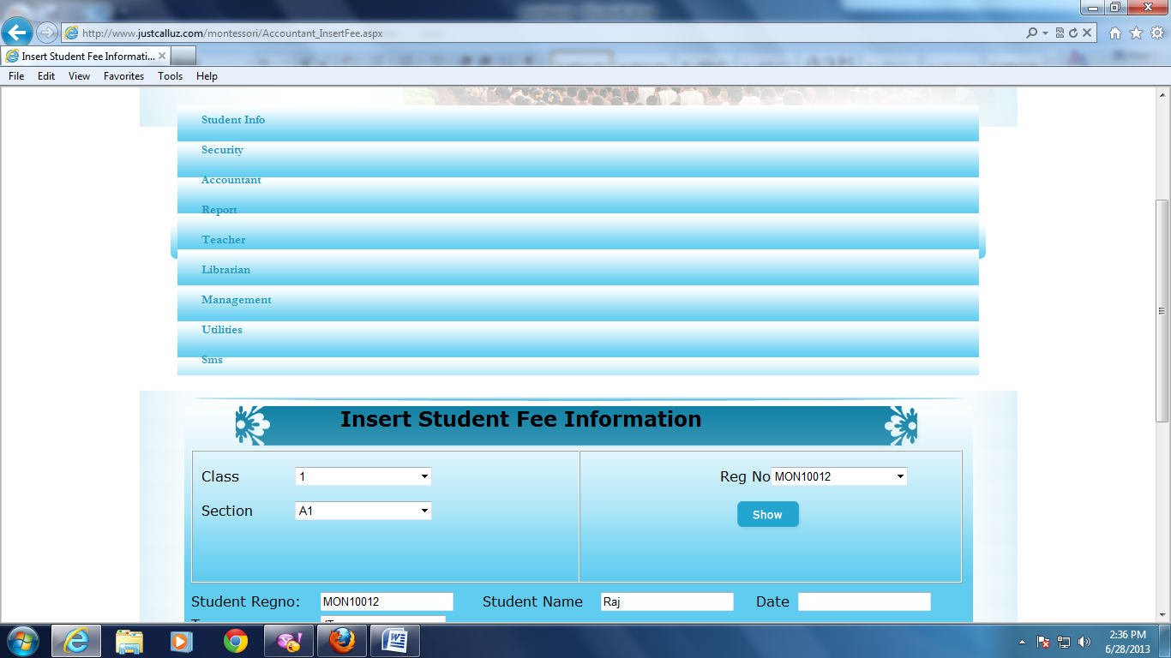

3. In update fee page when we select reg number and clicks on show then details are not bound.

4.In student fee info also same when we select reg number and clicks on show then details are not bound.

**Reports** :

1. when we select date and class,section if there are no records,even though the file is downloading. **(**fixed**)**
2. same for print also.
3. same for student fee report also. **(**fixed**)**

**Management** : (fixed)

1. submit button path should be changed.
2. in setup class fee there is no read only property for total fee
3. if we give more digits it is accepting and th error is

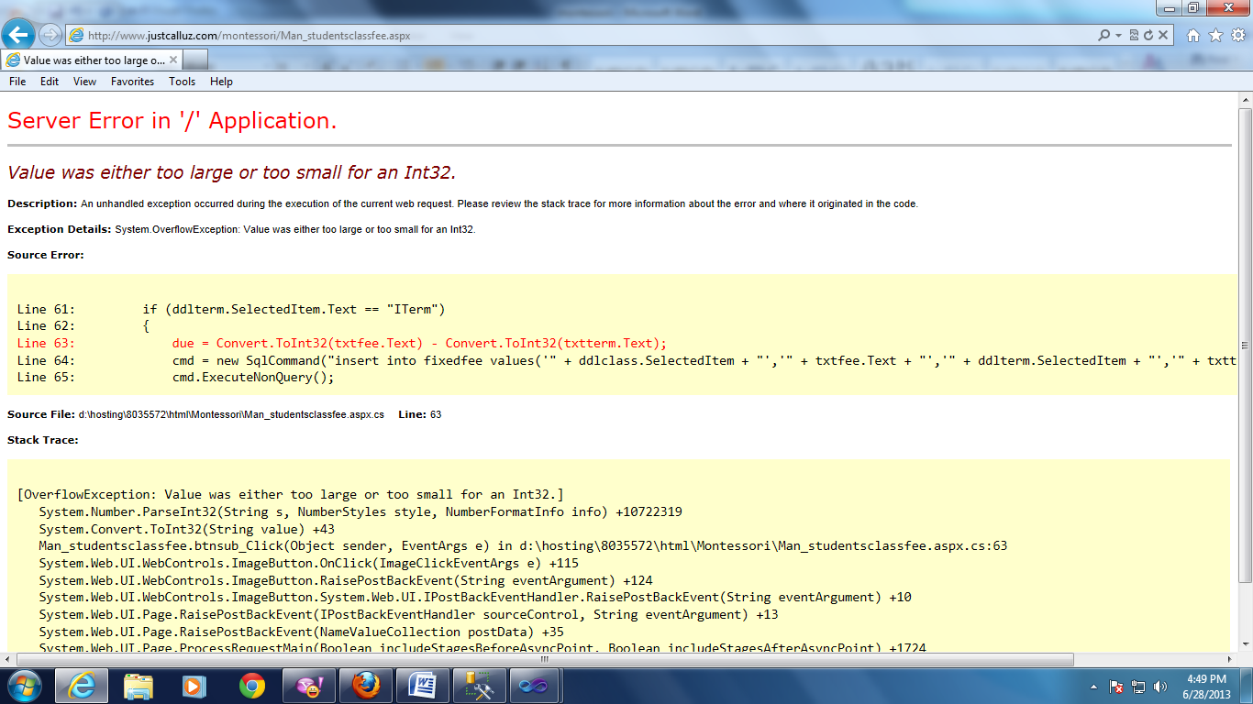

**security** : **(**fixed**)**

1. image is not displayed when name is available

**Teacher: (**fixed**)**

1. for attendence form there is no alert message for present button.
2. there is no validation for hindi and english accepting 3digits number.
3. in show marks page replace show button
4. for update it is accepting letteres also due to that the error is raised

